Hanoi Tower Activity

#### **Learning Outcome Addressed**

 4. Write recursive functions

Now you can practice solving the Hanoi Tower problem in Next Tech. Click the link below to launch the activity in a new window and follow the instructions.

**Recursion To Solve The Hanoi Tower Problem**

### Hanoi Tower

Now that you're familiar with the Hanoi Tower problem, you can explore how to customize its algorithm to add more disks.

The starter code for this activity includes the solution to the Hanoi Tower problem. Currently, this solution works for five disks only.

You can use the application by pressing the Make Move button. The first press will load the Hanoi Tower. Every button press after that iterates through solving the Hanoi Tower. When the Hanoi Tower is solved, on the last button press, you will receive an alert stating Tower is Finished.

Note: The integrated web browser is too small on most screen sizes to display the entire Hanoi Tower application. Use the "Open in new browser tab" button. See the screenshot below.

[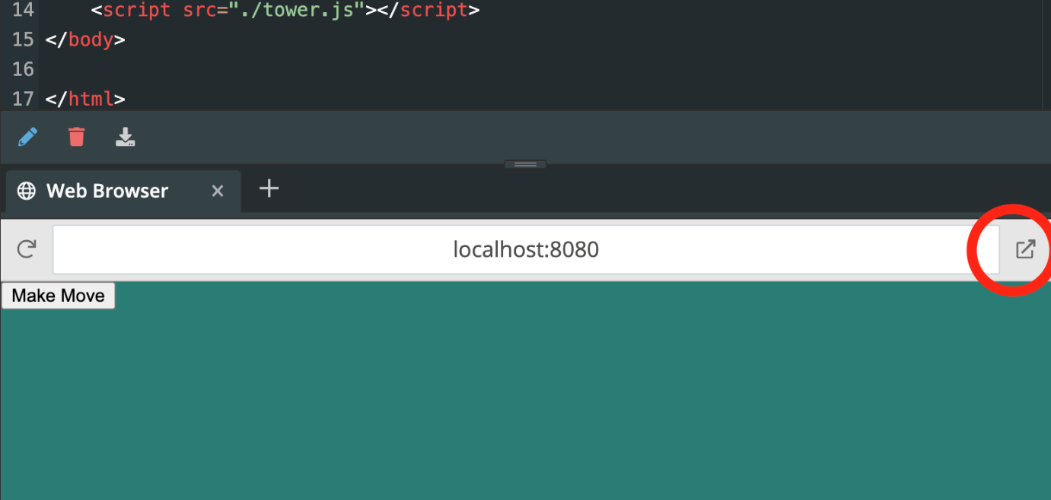](https://cdn.filestackcontent.com/QjOq0hp6RNmqGTFhlcOq)

**Your task in this activity is to edit this solution to add a custom number of disks to the tower.**

You can accomplish this task by doing the following:

* Add an input box with the ID: numDisk under the make move button in the index.html file. This input box will contain the custom number of disks.
* Use the input from that box to adjust the Hanoi Tower algorithm to account for all the disks.

Hint: In the *tower.js* file, find the *makeMove* function. Then think about how to retrieve the value that the user typed in the *<input>*. Finally, consider where in the function to set the *nDisks* variable to the user's input value.

Task

Edit the hanoi tower algorithm to add a custom number of disks to the tower